**Hazardous Air Polluants (HAP)**

Air pollutants are substances found in the atmosphere that are harmful to human health and other living organisms. Air pollutants can be found in different states, particulate, gaseous and biological molecules.

HAP also known as toxic air pollutants which is a subcategory of air pollutants is defined by the EPA as “pollutants that are known to cause cancer or other serious health effects, such as reproductive effects or birth defects, or adverse environmental effects”.

Examples of HAP include benzene, which is found in gasoline, mercury, lead compounds, methylene chloride etc. The EPA is currently working to reduce air emissions of 187 HAP to the environment.

**Our Analysis**

Our analysis is based on daily HAP recorded different states in the US from 1990 – 2017. The data was then grouped in 2: Carbon HAP and Non-carbon HAP.

The goal of or analysis is to obtain/ get in-sight into the HAP levels (for one state) over the duration of the data and get some insight into the following questions.

* Which counties have the highest and lowest HAP?
* What are the best and worst counties for carbon and non-carbon HAPs in CA?
* What is the most prominent HAP?
* What populations were at risk?

**Cleaning our data**

Our dataset was obtained from Kaggle. The source dataset was made up of a total of 8 million+ rows and 29 columns.

We decided to analyze the data from the state of California and reviewed the entire dataset for NaN values, next we decided to analyze the data from the state of California and removed/ dropped columns that did not have relevant information to our analysis. Examples of such columns were:

“CBSA Name”: The name of the core bases statistical area (metropolitan area) where the monitoring site is located.

“Method Name”: A short description of the processes, equipment, and protocols used in gathering and measuring the sample

“AQI”: The Air Quality Index for the day for the pollution, if applicable

These activities helped narrow down the number of rows to **872461** and **17** columns for the state of California. Of these datasets the non-carbon HAP (with units other than parts per billion carbon) were made up of **479734** rows and **17** columns and the carbon HAP was made up of **392727** rows and **17** columns.

New columns were created as well during our analysis, example of these columns is:

“month”, “day” and “year”: to help run analysis without using conversions.

“first_max_value_in_NG” – to convert the “units_of_measure” for daily recordings from microgram to nanogram etc.

**Summary Statistics**

The summary statistics was performed on both the source dataset from Kaggle (8 million+) and the cleaned data for the state of California, this was to help determine if the outliers in California dataset were to be kept or dropped. From the summary statistics for the entire data, for the state of California, carbon HAP and non-carbon HAP dataset is below.

|  |  |  |  |  |
| --- | --- | --- | --- | --- |
|  | Kaggle Dataset | California Dataset | Non-carbon HAP Dataset | Carbon HAP Dataset |
| Mean | 0.561897 | 3.165112 | 2.740759 | 1.304063 |
| Median | 0.000890 | 1.000000 | 1.000000 | 0.120000 |
| Standard Deviation | 13.62156 | 15.968621 | 11.348834 | 14.876403 |
| Maximum Value | 20000.000000 | 9051.100000 | 1112.300000 | 9051.100000 |

**Data Visualization**

As stated above the dataset was subcategorized into 2, Carbon based HAP and Non-carbon-based HAP. Using matplotlib, we have a bar plot/ chart with an overlapping line plot/ chart of the 2 subcategories for the state of California from 1990-2017. The average HAP levels of the of the data were used for this analysis.

**Non-carbon-based HAP:**

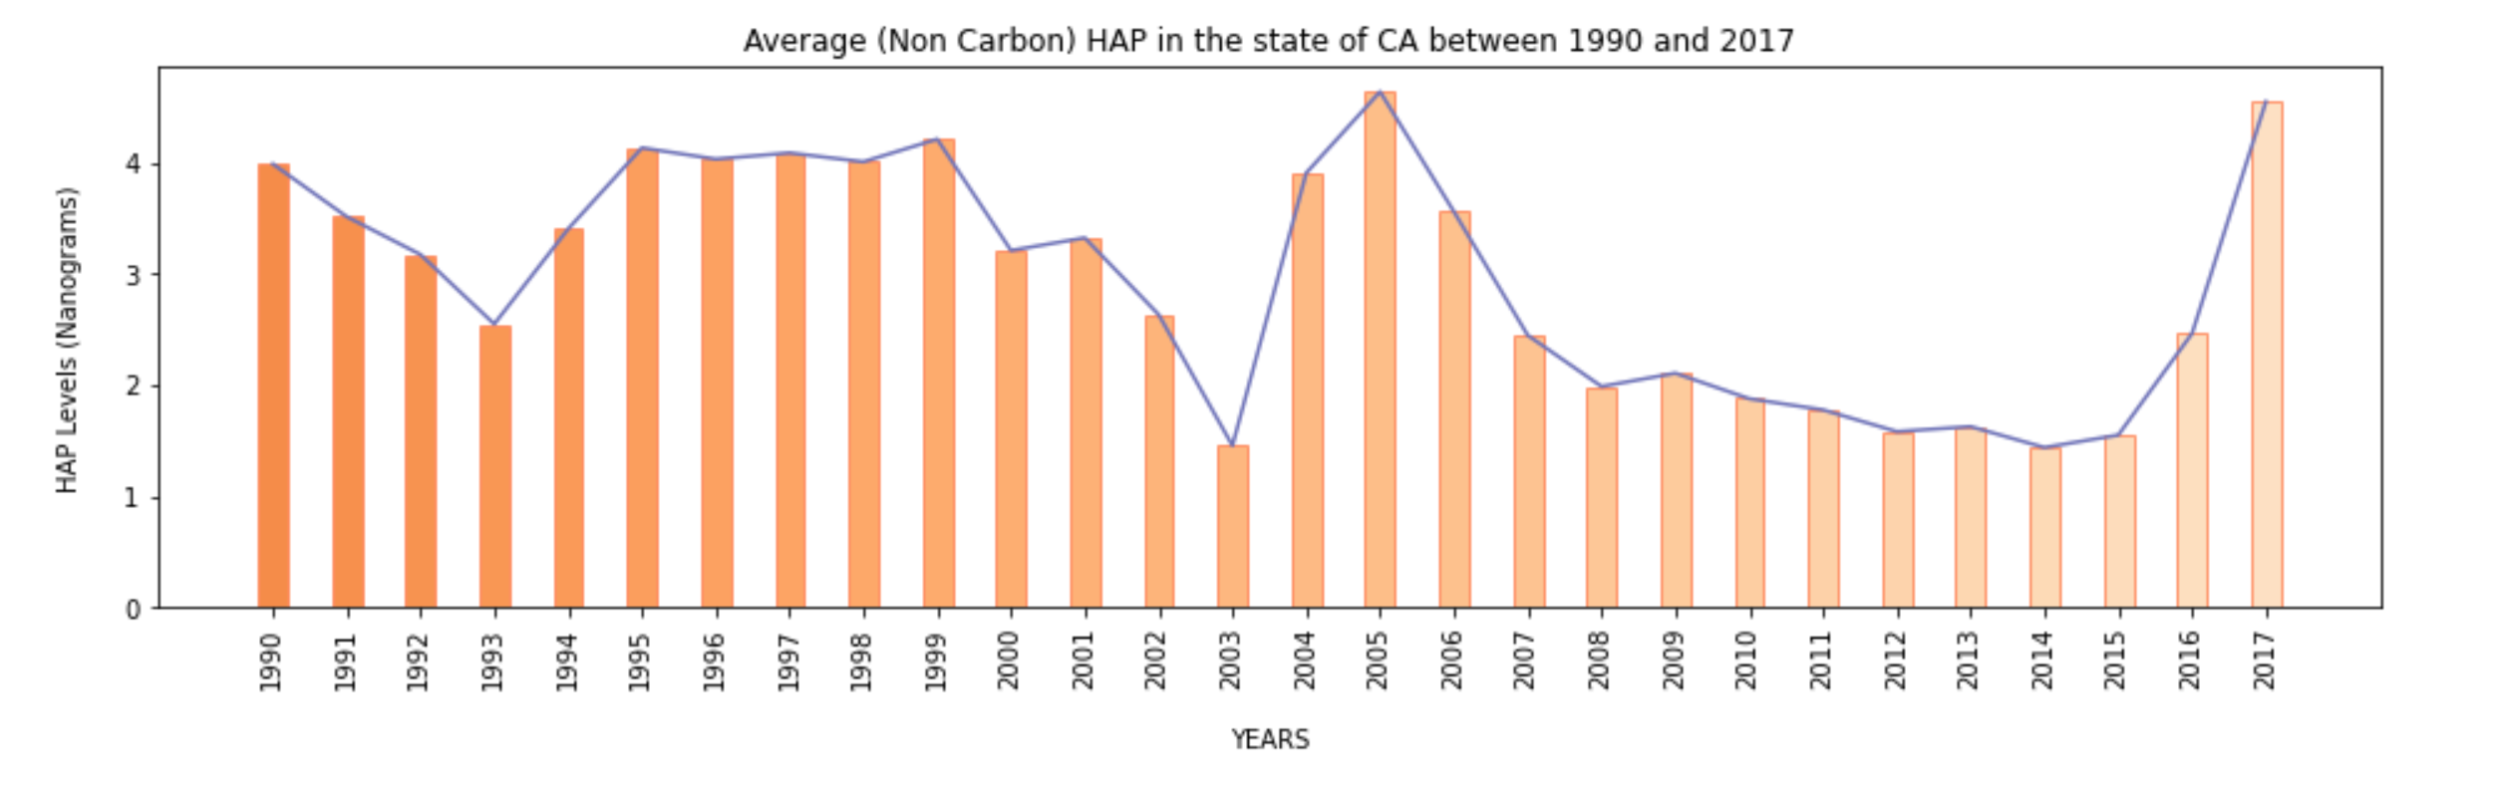

From the chart of the average first max values through the years for California, we see a decline in HAP levels in general for non-carbon-based HAPs from 1990-1993, after 1993 we see an increase in the non-carbon HAP levels until 2003 where a huge drop is observed. The pattern follows the drop and rise but it is interesting to note the great increase in 2017. Our analysis is going to explore the data by looking at counties from the beginning/ starting date of the data 1990 which will be base of our data to the end date of the data 2017, we are going to find which counties contributed to the spike, what non-carbon HAPs were emitted and what cities within the counties emitted the HAPs using a heatmap.

**What are the best and worst counties for carbon and non-carbon HAPs in CA?**

From the summary statistics table above, we see the non-carbon HAP have a higher mean than the carbon HAP which is better considering carbon HAPs are much more influential in causing harm to the people and the environment in general.

We then proceeded to create bar charts for every year of the data available to visualize the top five best and worst counties for carbon and non-carbon HAP.

Non-Carbon HAP:

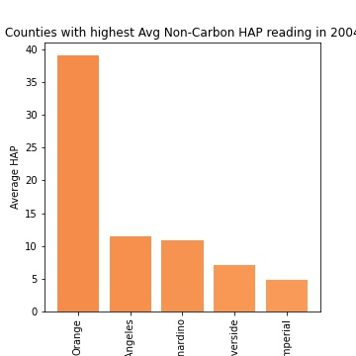 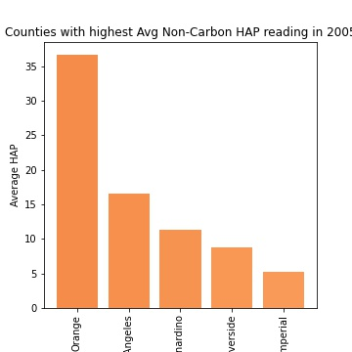 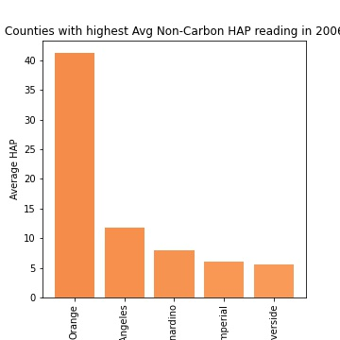

Orange county had a very high spike of non-carbon HAP in the years 2004 to 2006. The non-carbon HAPs were around 40 when the mean is around 3.19.

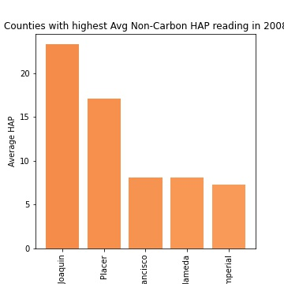

In 2008 San Juaquin had a spike of around 25 NG of non-carbon HAPs.

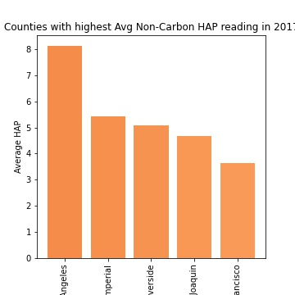 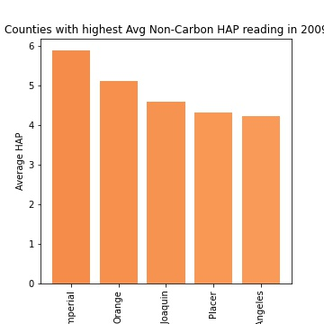

Since 2009 most of the average non-carbon HAP for all counties in CA have been around 7 or under. This shows that the non-carbon HAPs in the worst counties have not increased over this period.

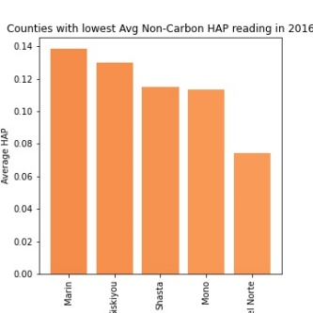 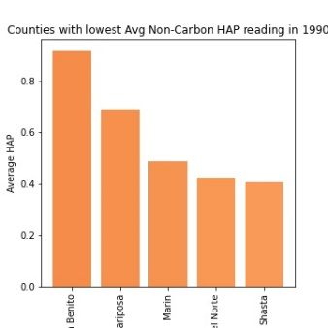

From 1990 to 2016 – the lowest non-carbon polluting counties had a average of less than 1 NG of non-carbon HAP.

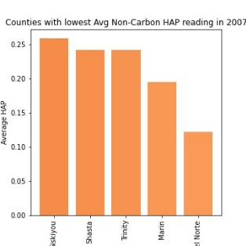 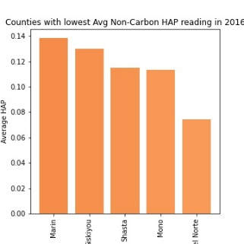

County of Marin again was in the bottom five for non-carbon HAP from the year 2007 to 2016. This shows that Marin has a good control on both carbon and non-carbon HAP emissions.

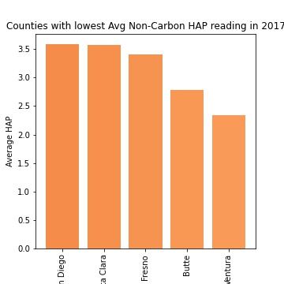

2017 saw a spike for non-carbon HAP across all counties with the bottom five jumping almost 20 times the average in 2016. It might be because of a major natural disaster or a major catastrophe that caused the spike across all counties.

**Carbon based HAP:**

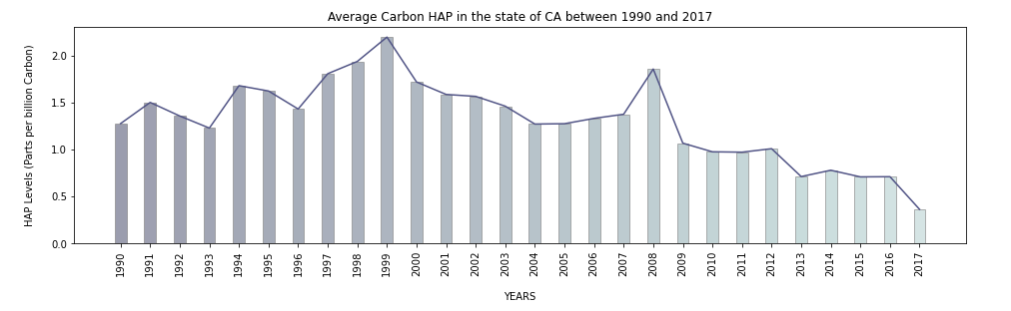

From the chart for carbon HAPs, we see some rise and fall in the levels of HAPs as well but unlike in the case of the of non-carbon HAPs where sharp rises and drops are observed. A common trend was observed in 1993 where there was a significant drop in both HAPs carbon and non-carbon.

Our analysis is once again going to explore some select years where increases in the HAP levels were observed starting with 1990 and ending with 2017.

**What are the best and worst counties for carbon and non-carbon HAPs in CA (cont’d)?**

Carbon HAP:

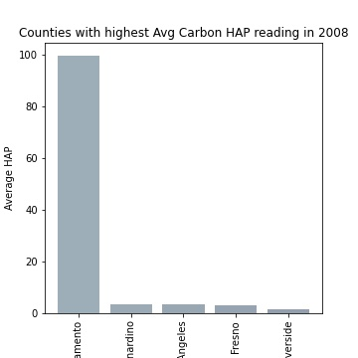

The above chart for the year 2008 showed the absurd levels of carbon HAPs in Sacramento. This was an alarming find and the reasons for this incredible spike should be investigated to make sure that this is not a recurring phenomenon.

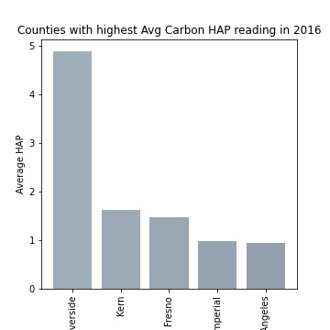 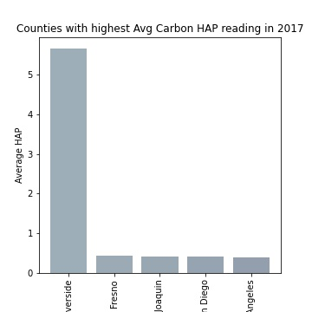

The above charts show the carbon HAP levels in 2016 and 2017 and Riverside is clearly the worst county in regard to carbon HAP. While others are closer to the mean Riverside is almost 5 times the mean in both years. Barring Riverside, the highest carbon HAP has been under 3 since 2008.

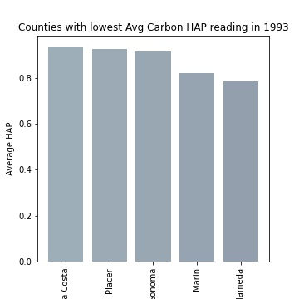 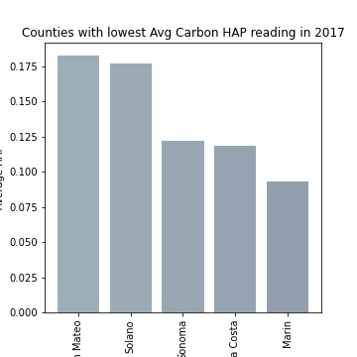

The above charts are for the counties with the least carbon HAP in 1993 and 2017. As you can notice Marin appears in both in the bottom two. As a matter of fact, Marin has been in the bottom 2 since 1993 showcasing its strength in controlling carbon HAPs over a long period of time.

Since 1993 bottom 5 have an average under than 1 NG of carbon HAP and since 2000 bottom 5 have an average of under 0.5 NG carbon HAP which is less than 50% of the mean.

**Are the HAP levels increasing or decreasing for each county? And What population is currently at risk?**

After the analysis of the counties with the highest HAP levels/ emissions we the decided to further explore which HAPs were emitted by the counties that had the highest emissions to give us an idea of the population at risk. We selected years with the most increase or decrease in HAP levels to help with our exploration.

Non-Carbon HAP:

|  |  |  |
| --- | --- | --- |
| Year | County | Non-carbon HAP |
| 1990 | Riverside | Manganese |
|  |  | Chromium |
|  |  | Nickel |
|  |  |  |
|  | San Joaquin | Manganese |
|  |  | Nickel |
|  |  | Chromium |
|  |  |  |
|  | Fresno | Manganese |
|  |  | Chromium |
|  |  | Nickel |

|  |  |  |
| --- | --- | --- |
| Year | County | Non-carbon HAP |
| 1993 | Riverside | Manganese |
|  |  | Chromium |
|  |  | Nickel |
|  |  |  |
|  | San Joaquin | Manganese |
|  |  | Chromium |
|  |  | Nickel |
|  |  |  |
|  | Fresno | Manganese |
|  |  | Chromium |
|  |  | Nickel |

|  |  |  |
| --- | --- | --- |
| Year | County | Non-carbon HAP |
| 2017 | Los Angeles | Manganese |
|  |  | Chromium |
|  |  | Nickel |
|  |  |  |
|  | Imperial | Manganese |
|  |  | Chromium |
|  |  | Nickel |
|  |  |  |
|  | Riverside | Manganese |
|  |  | Chromium |
|  |  | Nickel |

The table above gives a snapshot of the top 3 contributing counties and the top 3 non-carbon HAPs that were emitted by the counties respectively in the order of highest to lowest over some select years.

And below is the snapshot for the top 3 counties with the most non-carbon HAP and the top 3 HAP for each county for 2017 in the form of a pie chart.

Non-carbon HAPs for 2017

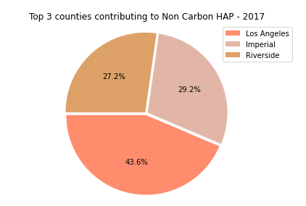

The breakdown of the HAPs per county are depicted below:

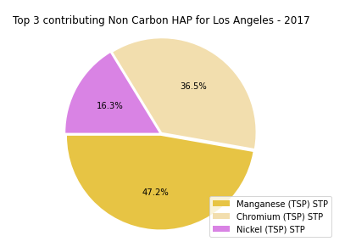 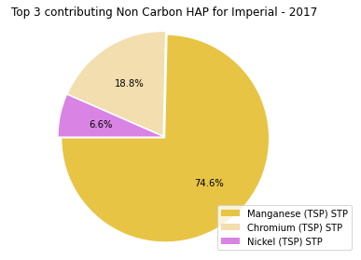 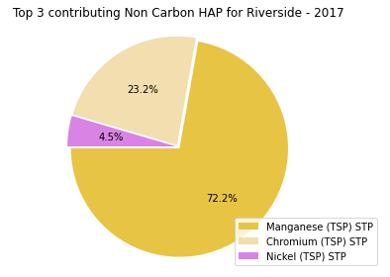

It was observed that manganese was the highest non-carbon HAP emitted over the years. Manganese is mainly used by the steel industries as a deoxidizing and desulfurizing additive to help make the steel malleable for forging. Chromium is also used in the steel industry to harden steel during the manufacturing of stainless steel, they are also used as industrial catalysts and pigments. Next prominent non-carbon Hap is Nickel which is also used in the steel industry as ferronickel. Other uses of nickel include batteries, kitchen ware just to name a few. The presence of these HAPs along with the uses of the highest 3 HAPs leans towards the presence of a steel factory in these counties or surrounding counties. All population are at risk as they can develop illness such as metal fume disease, Pontiac and even Parkinson-like tremors but the population with auto-immune diseases, cancer etc.

Carbon HAP:

|  |  |  |
| --- | --- | --- |
| Year | County | Carbon HAP |
| 1990 | Santa Barbara | Benzene |
|  |  | Dichloromethane |
|  |  | Tetrachloroethylene |
|  |  |  |
|  | Kern | Benzene |
|  |  | Dichloromethane |
|  |  | Ethylene dichloride |
|  |  |  |
|  | Santa Clara | Benzene |
|  |  | Dichloromethane |
|  |  | Tetrachloroethylene |
|  |  |  |

|  |  |  |
| --- | --- | --- |
| Year | County | Carbon HAP |
| 1993 | Los Angeles | Benzene |
|  |  | Acetaldehyde |
|  |  | Formaldehyde |
|  |  |  |
|  | Kern | Benzene |
|  |  | Acetaldehyde |
|  |  | Tetrachloroethylene |
|  |  |  |
|  | San Bernadino | Benzene |
|  |  | 13-Butadiene |
|  |  | Dichloromethane |

|  |  |  |
| --- | --- | --- |
| Year | County | Carbon HAP |
| 2017 | Riverside | Dichloromethane |
|  |  | Benzene |
|  |  | Acrolein |
|  |  |  |
|  | Fresno | Benzene |
|  |  | Acrolein |
|  |  | 13-Butadiene |
|  |  |  |
|  | San Joaquin | Benzene |
|  |  | Acrolein |
|  |  | 13-Butadiene |

The table above gives a snapshot of the top 3 contributing counties and the top 3 carbon HAPs that were emitted by the counties respectively in the order of highest to lowest over some select years.

And below is the snapshot for the top 3 counties with the most carbon HAP and the top 3 HAP for each county for 2008 in the form of a pie chart.

Carbon HAPs for 2017

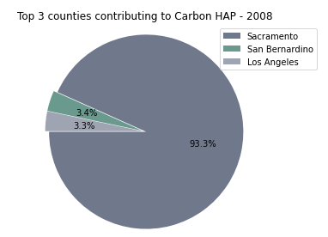 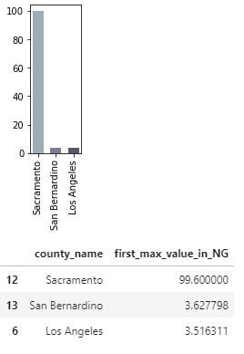

The breakdown of the HAPs per county are depicted below:

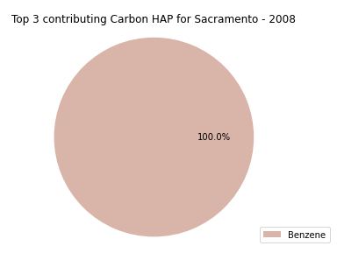 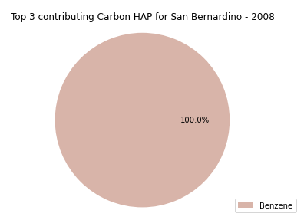 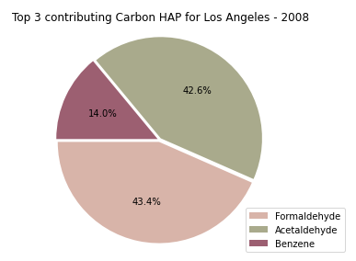

Benzene was the prevalent carbon HAP in California, carbon being a very reactive can react with many compounds and metals to form several. Tourism, migration, natural disasters all contribute to the emission of carbon HAPs. Benzene is used to make other chemicals like plastics resins. 13-Butadiene is a versatile material that is used for synthetic rubbers. Dichloromethane are industrial solvent found in paint removers etc. Benzene, which is very carcinogenic causes cancer, other compounds causes birth defects and many more. Like in the case of the non-carbon HAP affects all population are affected.

These HAPs also affect the air quality and gives rise to fog/ smog, allergies and other respiratory diseases.

**What populations were at risk?**

# Heatmaps for Carbon and Non-Carbon Haps

The heatmaps were generated for the purpose of visually displaying where the data was captured during the timeframes of the study and to allow viewers to develop inferences as to where the data would be clustered and what populations might be affected by the location of these HAPs. The heatmaps are displayed with the mean of the gathered data being displayed, and the maximum value of all means being displayed as the maximum intensity of the heatmap, so as to allow for an effective index.